Cultural Collections Project 1: Google Maps

This project introduces you to collaborative Google mapping of cultural themes. When we are in Sweden, you will be contributing at least five pins to a shared Google map. Each pin on a map will include a link to an image or video you have taken, as well as an annotation that describes the cultural element being shared on the map. The annotation should be informative with some facts about the item shared and how it is representative of Swedish culture, not just a selfie that says, “Me in a Swedish grocery store.” Your contributions to the map should educate others as to the significance of a given cultural item. Share things that teach some history or have a background/story. Talk to people and find out about the cultural items you are sharing.

Step One, Take Media: Step one is to take photos or videos of items that represent Swedish culture. For example, you may see one of Stockholm’s famous trams rolling by and record a video, or you may see kids playing an unfamiliar game in a park and snap a photo. Take note of where the media were captured, as you will need this info in step three.

Step Two, Open the Shared Google Map: The culture map we are collaborating on this semester has already been created. Open this map to get started:  https://drive.google.com/open?id=1X5-qRaHNj1vzSaZfhvh12taze-M&usp=sharing  The map is semi-public, so anyone with this link can add pins to the map. | 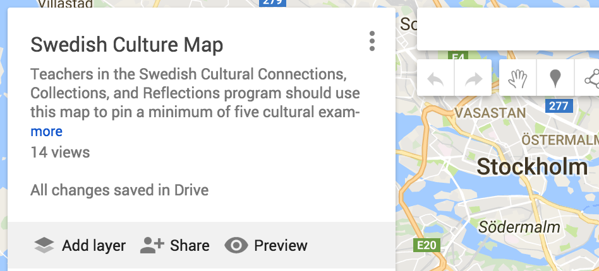

Step Three, Zoom-In: Find the location of the cultural item you want to share on the map. Use the plus/minus arrow to zoom into the map. You can also click and drag to move a map left-right-up-down.

If you want to use the search bar to find a place or location, you can do that, then click “Add to map” to add a pin for that location to the map. Next, click the “pencil” icon to edit this pin’s details.  If you have trouble with the “Add to map” option, try changing browsers. I had trouble with this step using Chrome, but it worked with Safari (go figure--you would think Google Maps would work with Google Chrome!). | 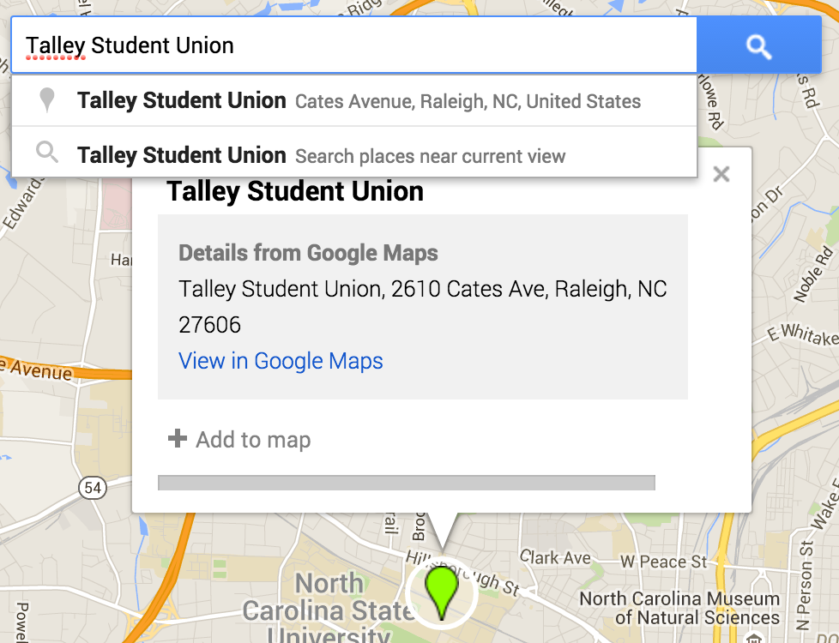

Step Four, Add or Select a Layer: Layers will allow us to sort our pins into cultural categories (e.g., transportation, customs, food and drink). The map will start out with no layers, but you can add layers to fit the cultural items you are pinning, or you can pin cultural items under the layers already created by your classmates. BEFORE adding a pin, create a layer or click the existing layer you want to add a pin to, and a blue bar along the left of the layer will indicate which layer is active. If you accidentally add a pin under the wrong layer, you can drag and drop it under the right layer. Please don’t delete others’ layers, as you may inadvertently delete their pins as well. | 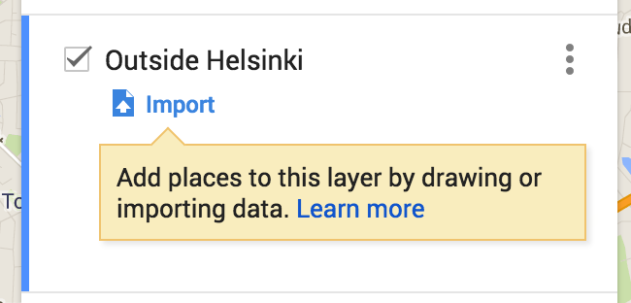

Step Five, Drop and Edit Pin: When you’ve zoomed-into the appropriate location, click the pin icon on the menu bar, then click once on the map where you want to drop the pin. This will open an edit window where you can begin to enter information about your pin.  Give your pin an informative title, so someone can identify what cultural item you are sharing by the title. The title will appear in the map menu.  Under the title, write your annotation about the item. Again, give some details, educate the reader about this item. How does this item represent Sweden and a cultural theme? | 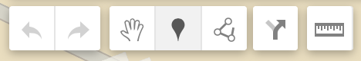  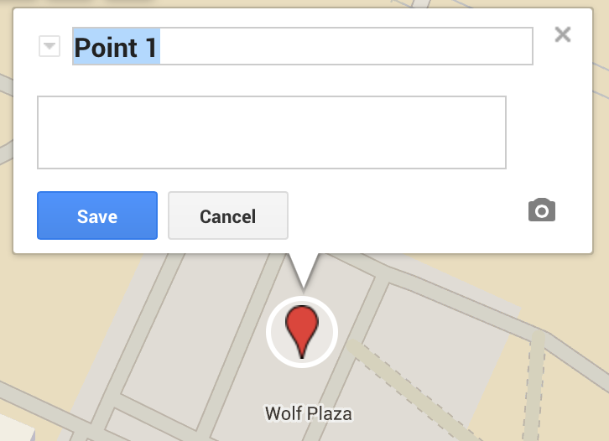
Finally, click the camera icon to add your photo or video to the pin. When you click the camera icon on your placemark, it will open another window to drag and drop your photo/video or to select the file on your computer. Finally, click “Save” and you pin will be added to the list of pins for this map. If your pin was accidentally added under the wrong layer, you can drag and drop it under the correct layer. | 