Cultural Reflections 6: Immersive Narrative (Bubbli App)

Step One: Plan Topic/Settings
In small groups of at least three, plan a story in which setting will play a major role. Use a table like the one shown here. As we would like your story to use more than one setting (at least two for your Raleigh story, and four for your Helsinki story), you may need more than one table.

Time: | Summer in Helsinki
Place: | A bed and breakfast in the Puu-Vallila or Puu-Käpylä historic district
Details of Setting that Affect Mood or Tone: | outside: colorful wooden houses along the shoreline, cloudberries, soft sound of rain  inside: an interesting vibrant person; a shy person; a puppy, candlelight, champange on a silver tray
Details of Setting that Reveal Character: | a travel diary, a book of poetry, a locket

Your story should demonstrate that you understand the cultural significance of different settings by situating an appropriate story in that setting. Your story should also educate the non-Finnish public about the cultural significance of different settings, so if one of your American friends back home viewed your story, they would learn something about Helsinki or Finnish culture. For example, when visiting Helsinki, you might see some demonstrators outside of the national parliament building in Helsinki, or in the public Senate Square. Your story, then, might include one Finnish and one American college student discussing proposed cuts to higher education funding in Finland that have resulted in new tuition for international students. These students might be waiting on a demonstration to begin in Senate Square near the University of Helsinki. A short script at this scene might say something like this:

Pirjo: Adam, I’m afraid my country’s introduction of tuition on international students will drive students like you away, and we won’t benefit from learning together.
Adam: It’s true, no tuition was a big factor in why I chose to attend the University of Helsinki. When is the students’ demonstration starting?
Pirjo: It should start in about 20 minutes.
Adam: Are public demonstrations the norm here, and are they always here at Senate Square?
Pirjo: Yes, Finns do protest peacefully, and most protests are either here or in front of Parliament.

Current events like those discussed above make good fodder for stories, but your story can be a romance, a historical drama, or anything you wish.

Step Two: Prepare Script
Segment your narrative into 2- and 4-scenes respectively for the Raleigh and Helsinki stories we will be working on, and write a draft script that involves two persons or two actors discussing your topic across the different settings you have selected.

** Keep your scripts short. Bubbli only records a short amount of audio (~30 seconds). **

Step Three: Capture Bubbli Images and Spoken Audio Script
Use the Bubbli app available for iPhone to capture immersive bubbles in your different settings. You will need three persons to complete this step--two actors will need to pose and speak aloud the script while a third person captures the bubble image. I recommend capturing each scene at least twice, because Bubbli can be buggy and temperamental and sometimes the images you capture do not build/load correctly and can’t be played back.

You can use the Bubbli app offline, and when your iPhone/iPad is connected to data/wifi, the images will upload and build into a photo sphere automatically. The email address you entered when you signed up for Bubbli will receive an email when each of your Bubbli’s has been compiled and is ready to watch/share. | 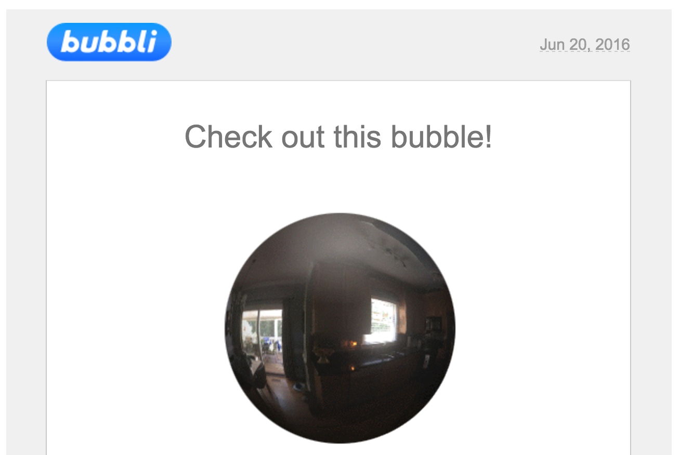

Step Four: Test, Play Back Your Bubbli’s
When you open your Bubbli image, you can click and move the image around in a 360-degree circle. You will see three icons in the upper right-hand corner of your image. The first placemark icon indicates the location of a bubble sphere on a map. The second arrow icon allows you to copy a link to your bubble image or embed code to place your bubble image on another Web page. The third sound icon allows you to click and play the audio captured when you took the bubble image. | 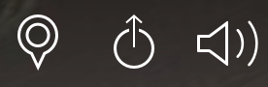

Step Five: Share Your Immersive Narrative
Bubbli does not allow you to download and save a bubble image; rather those stay in the cloud. Instead, you can grab embed code for each bubble created to share on your Weebly portfolio page. To get embed code, you have to open the email Bubbli sends you after building your image, then open the link to your bubble, then click the share icon.  For your project, then, you will need to grab 2 to 4 different sets of embed code from Bubbli and paste those into the "custom HTML" blocks we have pre-populated onto your Weebly portfolio pages to share your story.  If one person in your group created all of your Bubbli’s, that person will need to share the embed code with the others in the group, so all of you can post your immersive narrative segments on your Weebly portfolio page. | 